TODO:  
Cater to UPRM’s particular situation

Gather Data from professors

Flesh out Act & Standardize

# 

# Problem Background

Attendance to classes is formally required by the university’s policy, but the way in which it is enforced varies wildly by professor.

The common current forms of taking attendance often involve the professor passing around a sheet of paper for students to sign or for the professor to call the students’ names one by one. These approaches require a lot of manual and repetitive work for the professors and take away from the time that could be utilized for the lecture contents.

Professors need to manually go through their records of attendance to see which students are not attending their classes.

For larger classes that go to amphitheaters, it is not practical for professors to follow up on individual absences due to the sheer number of students. Hence, many students who could have possibly needed help or some outreach go unnoticed and possibly silently punished through grades or disciplinary action.

The NCES <https://nces.ed.gov/pubs2009/attendancedata/chapter1a.asp> has found that attendance is correlated with class performance, which further cements the importance of having effective ways of tracking it.

# Target

Students will have a way of easily verifying their attendance upon entering the classroom without taking any longer than 1 minute, and without interrupting the flow of the class. Professors will be able to see which students did not attend a lecture on a particular day in a convenient format without needing to verify the attendance of every singular student. Professors will be able to direct lectures without interruptions due to a student wanting their attendance marked. Students will need to be in the classroom to have their attendance be properly recorded and others students will not be able to easily forge the attendance of their classmates.

# Causes

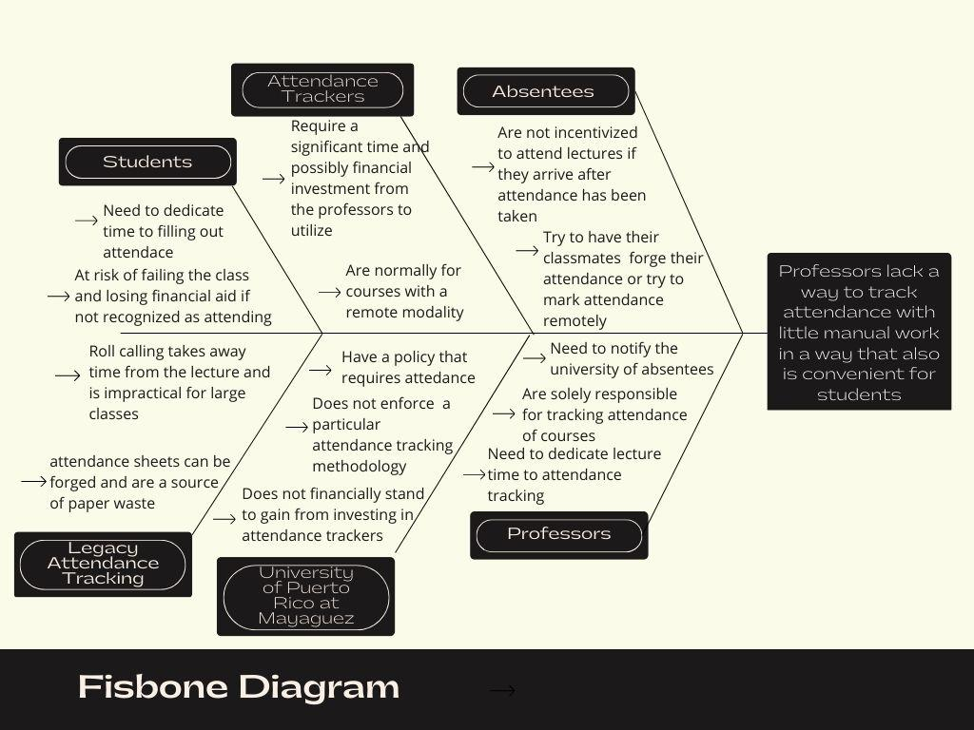

# Countermeasures

* A web based application which allows professors to generate attendance QR codes that students can scan on their phones to mark their attendance.
* Combine the attendance data gathered from each class to provide professors metrics about class attendance and lists of students with certain quantities of missed classes
* Prevent students from forging attendance for other students by limiting the number of people they can sign for per QR code

# Check and evaluate

* Data will be collected through surveys regarding the time that passes between the beginning of the class time and actual start of the lecture material in order to verify if the attendance tracking system successfully reduces the time dedicated to track attendance every class
* Professors will be asked to compare attendance numbers and personal/work time dedicated to analyzing attendance tracking with the expectation that the system described by the countermeasures significantly reduces this time.
* Additionally, professors will be surveyed on the ease of setting up the system, and to evaluate if the fixed amount of work to begin attendance tracking a new class with the system is justified by time savings in the long run.
* Students will be asked to answer surveys to measure the time that it takes them to mark their attendance and to offer insights about whether the system provides a significant improvement over traditional means of attendance tracking.
* Logging information could be sent to the server regarding the time it takes from the students to open the attendance website to the time the qr code is successfully read to have another point of data regarding the ease of use of the system.

# Act/Standardize

* A lot of real world situations merit attendance tracking. Seminars, Conferences, etc. The problem we are tackling regards situations where the focus is getting everyone who attends to notify the concerned parties of this, but the access to these events may not necessarily be restricted (ie. concerts). Hence, situations that fall under this are well suited for our system.
* This system could be integrated with the academic grading systems used by institutions to further reduce the work needed to be done by professors to incorporate attendance data.

# 